Register in the Web Homework System (WHS)
www.mathclass.org

Click Register in WHS

Complete the Account information
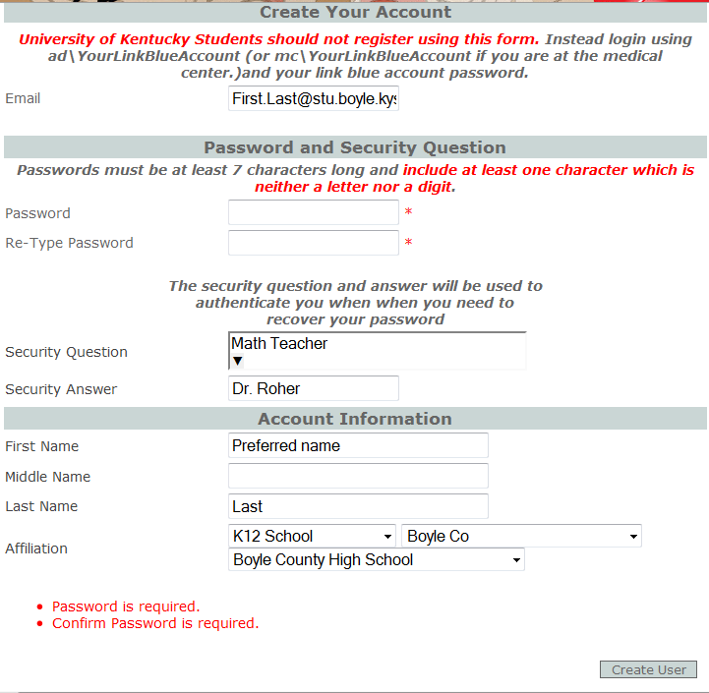
Note the Password
Instructions!!
First.Last@stu.Boyle.kyschools.us
When you have finished the account information; Click Create User
After you have created your account, click Continue
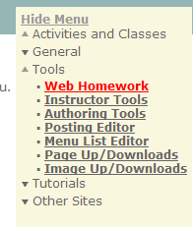
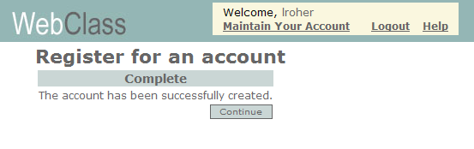
To add the class you will need to open Tools
(located in the menu), then click on Web Homework

Select 2013 Fall Geometry (Roher);
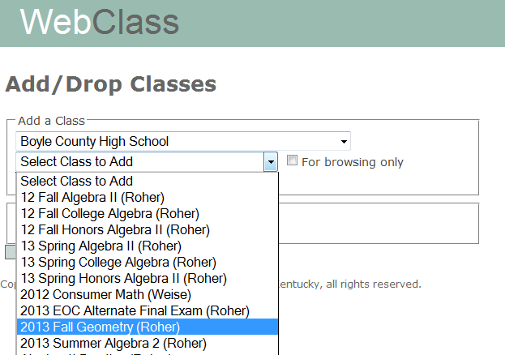

Click Add Class.

You will get a message Class added successfully.
Click Close Window and you will be ready to begin!

